COURSEWORK SUBMISSION FORM
STUDENT USE |  | STAFF USE
Module Name | Context of Business | First Marker’s  (acts as signature)
Module Code | 3BUSS002C | Second Marker’s  (acts as signature)
Lecturer Name | Alisher Ismailov | Agreed Mark
UoW Student IDs |  | For Registrar’s office use only (hard copy submission)
WIUT Student IDs | 00010170;00009464;00010384;  00009344;00010777
Deadline date | 5th of November, 2019
Assignment Type | GroupIndividual

SUBMISSION INSTRUCTIONS

COURSEWORKS must be submitted in both HARD COPY (to the Registrar’s Office) and ELECTRONIC unless instructed otherwise.
For hardcopy submission instructions refer to: http://intranet.wiut.uz/Shared%20Documents/Forms/AllItems.aspx - Coursework hard copy submission instructions.doc
For online submission instructions refer to: http://intranet.wiut.uz/Shared%20Documents/Forms/AllItems.aspx - Coursework online submission instructions.doc

MARKERS FEEDBACK (Continued on the next page)
CONTENT:
1.0 INTRODUCTION 3
2.0 OWNERSHIP 4
2.1 Types of ownership. 5
2.2 Leadership Team. 5
2.3 Structure. 7
2.4 Global hierarchy. 8
2.5 Performance-Based Divisions. 8
2.6 Functional-Based Groups. 8
3.0 FUNCTIONAL AREAS 10
3.1 HR 10
3.2 Brand 11
3.3 CFO Department 11
3.4 Legal 11
3.5 Restaurants 11
3.6 Operations 11
3.7 Supply chain and Franchisees 12
3.8 COO Department 12
BIBLIOGRAPHY: 13

2402 words
McDonald’s

1.0 INTRODUCTION
McDonald’s, one of the best-known catering corporations of 21 century, could be rightfully called the pioneer in the world of fast-food enterprises and the ideal embodiment of a successful American business. Over the years of its development, this franchise has gone through many transformations, from a simple eatery, based on the idea of providing consistently high quality fast food, to an incredible corporation with the largest chain of restaurants in the world, which currently consists of about 36,000 of restaurants in more than 100 countries around the globe.
Founded by brothers Richard and Maurice McDonald in the early 1940’s, McDonald has first introduced the speedy service system that was used in the efficient delivering of simple hamburgers in the drive-in restaurant of the small town in California (Corporate.mcdonalds.com, 2019).
Together with the benefits of modern for that moment service system, customers praised the restaurant for delicious food which cost affordable prices and which helped McDonald’s to get the leadership among the other nearby restaurants. However, despite the fame and success that accompanied McDonald's in those years, it could never go beyond the small town in California without the essential contribution of franchising agent and further the founder of McDonald’s System, Inc. (a precursor of the McDonald’s Corporation) Ray Kroc. Since becoming a franchise agent of McDonald's in 1954, Kroc has done an invaluable huge and abundant work in promoting franchise and in 1961 bought the rights for McDonald’s name and operating system which further helped his franchise and McDonald’s brand to get the worldwide fame (Mcdonalds.com, 2019).
Nowadays, McDonald’s continues to be a premier representation of one of the most popular companies in the world. McDonald’s restaurants supply its customers with fast food and beverages, which are considered to be locally-relevant. Regarding the products, McDonald's restaurants pay extremely high attention to offering a virtually unified menu, although there could be some variations in terms of producing the meal in different geographical areas to meet the expectations of customers from different regions (Sec.gov, 2019).
Besides, McDonald's is constantly testing new products to improve the restaurants’ menu constantly. All kinds of hamburgers, cheeseburgers, beverages, ice cream, and many other breakfast dishes can be found in McDonald’s fast-food restaurants as well as some completely new products, which would be available during the limited time.
Furthermore, to make its restaurants unique in many ways the company offers a variety of services and amenities to its customers. One of the convenient services, which is aimed to make the meal having time unforgettable, is the free WI-FI zone inside the franchise restaurants. WI-FI connection comes with ordered meals and can be truly described as a necessary amenity to get some works done and to check emails for absolutely free of charge (Mcdonalds.com, 2019). Another remarkable service is McDelivery, which is well-known as the service for ordering food right to people’s threshold (Mcdonalds.com, 2019). Moreover, McDonald’s also has “Arch cards” which are known as gift cards for frequent visitors and which can be purchased in any restaurant of franchise as well as at the shops like Walgreens, Safeway, Kroger, Giant Eagle and so on (Mcdonalds.com, 2019). Together with such simple privileges, the company also has its training program called Hamburger U, which was launched by Ray Kroc in 1961 and currently has about 275000 graduates (Corporate.mcdonalds.com, 2019).

2.0 OWNERSHIP
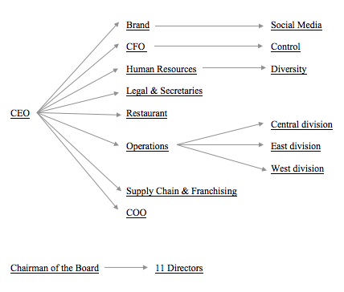
(HKDR, 2019)

2.1 Types of ownership.
First of all, there are 6 prominent types of property possession are widely known in the business such as Sole Proprietorship, Partnership, Limited Liability Company, Corporation, Joint Venture and Franchise. The franchise is a structure through which the corporation enables others to utilize its trademark, exchange name, or copyright, under explicit conditions.
McDonald's keeps on being perceived as a top franchising corporation around the globe, and stays focused on franchising as an overwhelming method for their business development.
The President and CEO generally manage the administration group of McDonald’s. The company also has seven official vice presidents and one senior vice president whose responsibilities include supporting company leaders and regulating a particular part of the business (Dudovskiy, 2019).

2.2 Leadership Team.
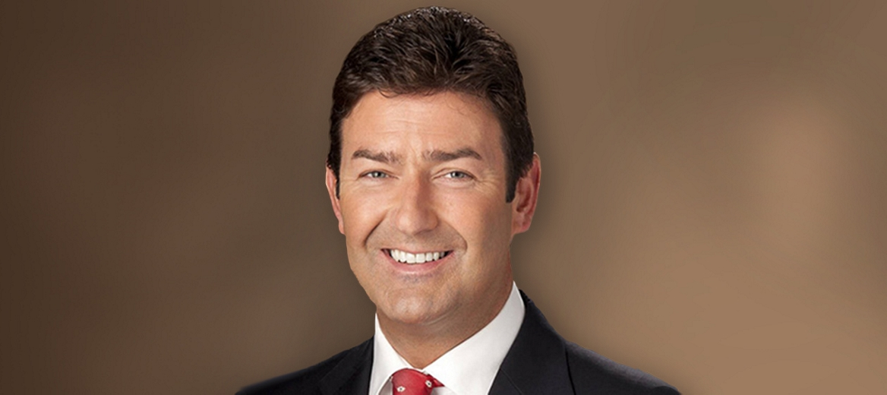
Since the beginning of 2015, the leadership of McDonald's has passed to Steve Easterbrook and after becoming President and CEO of the company Steve has driven it through a series of reforms in the organizational structure to improve its overall efficiency. (8) However, Steve’s career take-off was not instant since Steve himself joined the company in early 1993 as a Financial Reporting Manager in London and has since held a number of authoritative positions as Global Chief Brand Officer, President of McDonald's Europe and CEO of McDonald's in the UK before becoming Chief Executive of the company. In addition to his work at McDonald's, Steve also had management experience in two restaurant chains in the UK, which are PizzaExpress Limited, and Wagamama limited, which is also broadened his horizons in the franchise industry. Steve Easterbrook is a certified accountant by education and also the holder of a degree in natural sciences at Durham University (Mcdonalds.com, 2019).


Chris Kempczinski works as President of McDonald's in USA. His responsibilities include controlling business activities of about 14,000 McDonald's restaurants located in the United States. One of Chris' latest projects has been supervising strategies for planning and elaboration innovative concepts for developing McDonald's business. In that particular job, he was required to serve business units and franchises to identify new effective ideas and strategies, which would be essential in precipitating the general growth of the system (Mcdonalds.com, 2019). Before serving in McDonald’s Steve also had some leading positions in other worldwide known companies as Kraft International where he served as the President and Growth Initiatives at Kraft Foods Group, Inc. as Executive Vice President. Chris Kempczinski studied Duke University were received an undergraduate degree in public policy and economics and also graduated Harvard Business School where he held MBA degree (Chriskempczinski.com, 2019).
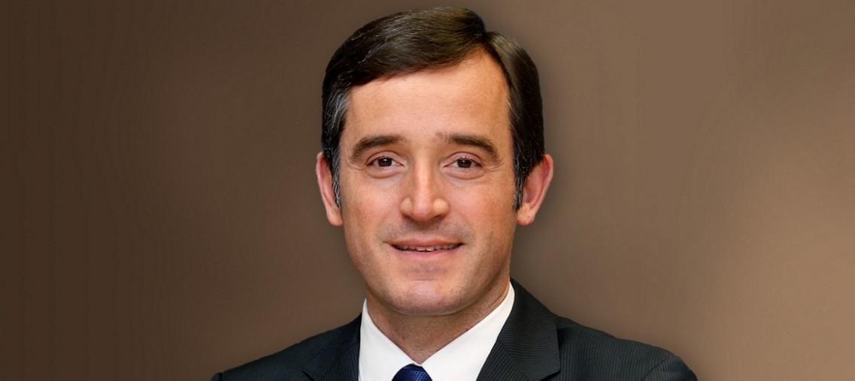
Mário Barbosa serves as the Zone President East for McDonald's in the USA where he drives brand development and engaged in accelerating the growth of the company in the long-term degree for more than 7,300 McDonald’s restaurants located in Eastern part of US. Mário Barbosa holds a degree in Business
Administration from the Catholic University of Lisbon. He started his career in the financial field and joined McDonald's Portugal in 1999 as Marketing Supervisor and moving up the career ladder, which led him to work as President and CEO of McDonald's Spain since October 2014, which was preceding position before becoming the Zone President East (Mcdonalds.com, 2019).

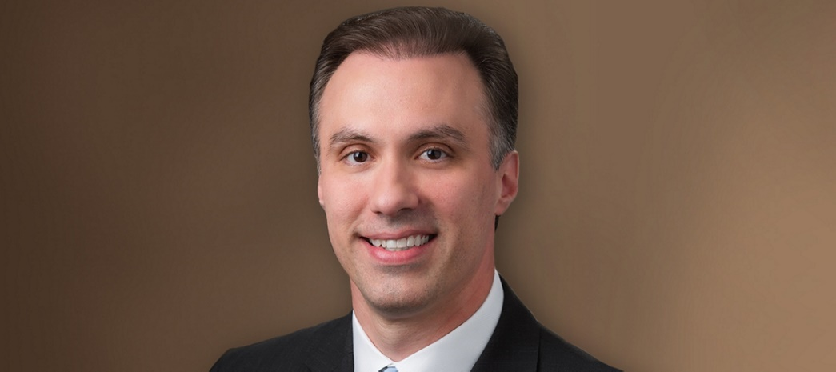
Spero Droulias is the Senior Vice President and Chief Financial Officer of McDonald’s in the USA. Не also leads the U.S. Finance organization and the organization named Business Insights in the territory of the U.S. Moreover, the number of posts held by him includes work as the Treasurer to Global Ronald McDonald House Charity and also as the Executive Sponsor of the McDonald’s Young Professionals Network (YPN). Before getting the position in McDonald’s Spero had extensive work experience in another enterprise called Ernst & Young where he was engaged in manufacturing clients and servicing consumer products. He joined McDonald’s corporation in 1995 and for a long time held several prestigious positions in American business, where he gained substantial field experience in the Chicago Region and in the U.S. Central Division of McOpCo which subsequently helped him successfully move up the career ladder. Spero Drulias is a Certified Public Accountant and graduated from DePaul University with a bachelor's degree in accounting and a master's degree in business administration in finance (Mcdonalds.com, 2019).

2.3 Structure.
The structure of McDonald’s is built on a linear-functional principle. The principles of centralism and unity of command are embodied in this structure. The head is endowed with all types of authority. Each subordinate has only one leader, and the head has several subordinates by the standards of manageability. The structure has also witnessed several reforms in 2015 to enhance the efficiency of dealing with its global operations. Currently, McDonald’s corporation choose the divisional organizational structure as main structure type for their franchise.
To be more conceptual, in this structure, each component on which the business company is divided should be obligated with certain responsibilities according to operational requirements. Each unit has a specific activity or set of vital goals. One of the points of this corporate structure is to help autonomous and hierarchical adaptability in fulfilling business needs in various markets. McDonald's organizational structure has the following attributes, managed by criticalness in influencing nourishment administration business tasks:
- Global hierarchy
- Performance-based divisions
- Function-based groups

2.4 Global hierarchy.
McDonald's Corporation has a worldwide pecking order to cover the company’s every single task on a global scale. This component of the organizational structure underscores corporate control concerning administrative control and heading. For instance, McDonald's CEO coordinates the exercises of all business zones through this auxiliary trademark. Commands and mandates are passed starting from the CEO to center directors, and to the restaurant managers and faculty in organization claimed tasks and among franchisees. This component of McDonald's corporate structure is conventional for worldwide business associations.

2.5 Performance-Based Divisions.
Performance-based divisions are the most unique element of McDonald's corporate structure. Preceding its rearrangement on July 1, 2015, McDonald has had the accompanying geographic divisions in its hierarchical structure: (a) U.S., (b) Europe, (c) Asia/Pacific, (d) Middle East and Africa, and (e) Other Countries and Corporate (OCC) including Canada, Latin America and Corporate. After the rearrangement, the organization utilized execution as reason for the new divisions in its hierarchical structure: (a) U.S., (b) International Lead Markets, (c) High Growth Markets, and (d) Foundational Markets and Corporate. The United States division gives the greatest provincial deals incomes to McDonald's. The mix of worldwide lead showcases likewise speaks to a significant piece of the organization's incomes. The high-development markets represent a little minority of McDonald's incomes, even though these business sectors present the impressive potential for business development dependent on quick monetary improvement.

2.6 Functional-Based Groups.
McDonald's supports functional groups in its corporate structure. For instance, in order to supply chain management McDonald’s has “Supply Chain and Sustainability group” or “People group” for HR supervision. Each gathering is under the administration of a corporate executive or senior manager. This hierarchical structure trademark empowers McDonald's Corporation to address the essential capacities in its business. Gatherings might be included or changed as the organization develops and its objective markets change (Panmore Institute, 2019).
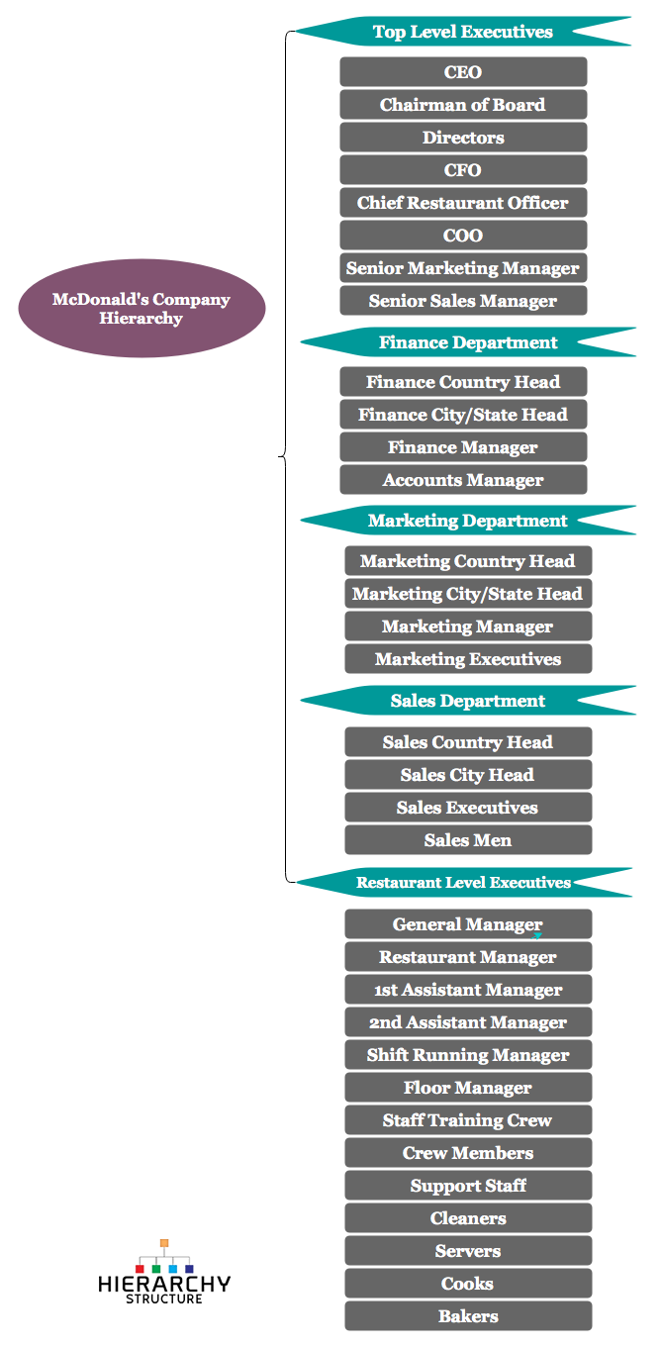
(Hierarchy Structure, 2019)

3.0 FUNCTIONAL AREAS
The Strategic arrangement of McDonald's is known as the 'Plan to Win'. The fundamental idea of this arrangement of McDonald's is based on the idea of being the best among the other fast restaurant chains. For accomplishing this, five P's are applied by the McDonald's: Product, Place, Promotion, Price, People (Fraser, n.d.).
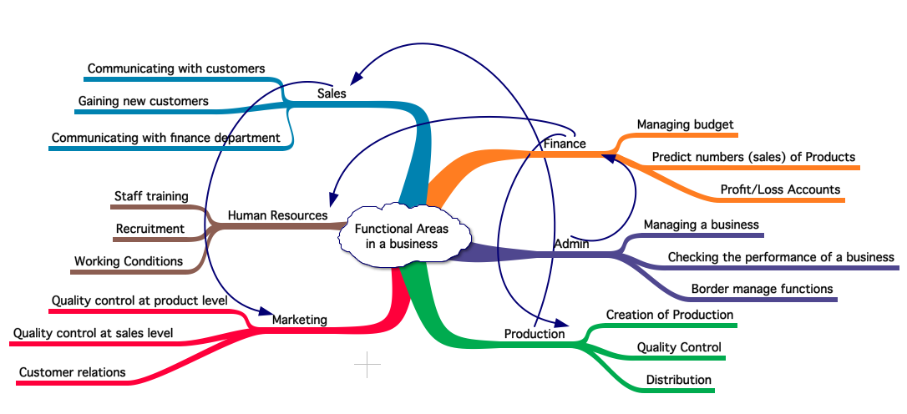
(HKDR, 2019)

3.1 HR
Human Resources - One of the main responsibilities of the Human Resources Department is concerning all subjects pertained to workers as well as about all enlistment of the staff. Physical fitness and security-related affairs together with, questions of guaranteeing McDonald's agreement to enact for representatives at workplace, relationship between employees which include liaison with unions, payment of benefits and compensations, setting policies regarding the salaries, confirming the competitiveness of wage and preparing and improving of overall efficiency of novice workers are all considered to be the responsibilities of HR Department.
Workers and clients play a crucial role in each of the associations, and this turns into the commitment of the association to tune in to the dissatisfaction of customers and representatives, which eventually would help to broaden the understanding of the association. The headway of the ordinary activities of the business is in like manner affected by the key human resource the board. This associate with knowing inside weak motivations behind the association so the structures for the future can be made in an ideal way (Fraser, n.d.).

3.2 Brand
The responsibilities of this department are mainly concentrated on developing the brand of the company. The major target of the brand department is establishing and developing McDonald’s brand name with the support of the Marketing Strategy. This imposes regular research of the market, constant developing of the product and the assistance of the sales department.

3.3 CFO Department
Chief Finance Officers Department is indebted to authoritative, budgetary and risk management operations of the company. This incorporates the improvement of a budgetary and strategy of risk management, control frameworks intended to save the organization's resources and generation of financial accounts.

3.4 Legal
One of the major obligations of the Legal department is procuring legal suggestions for any issues connected with McDonald’s company. The legal department office will deal with lawful agreements, renting deals, purchases of property, and issues with franchisees and so on. Moreover, composing the reports on changing legislations as well as assuring the legality of all operations of McDonald’s company is also tend to be the issues that lie on the shoulders of the Legal department.

3.5 Restaurants
This department’s main commitment is mainly related to the chain of fast-food restaurants of McDonald’s. They will provide a decent quality of the restaurants under McDonald’s franchise and will look for new properties. Inside every restaurant they will guarantee that it is working productively, staffed, accomplishing the most extreme deals income, agreeing to strategies on wellbeing and security, cleanness and following corporate rules.

3.6 Operations
The Operations Department deals with the association commitments basic for the ordinary running of McDonald’s, for instance, acquiring office supplies, telephone and utility contracts, the operations of rents rates covering and insurance. This process could be completed simultaneously for all chains of restaurants and the main office to economize the capital.

3.7 Supply chain and Franchisees
This department is responsible for ensuring the implementation of terms of an agreement concluded between suppliers and McDonald’s company. Numerous McDonald’s eateries are not claimed by the organization however possessed and keep running by franchisees which are accountable for conforming to concurred terms set by McDonald’s. This department will be liable for keeping up great relations and guaranteeing franchisee arrangements are maintained.

3.8 COO Department
The main obligation of the Chief Operating Officer's department is running the company daily (HKDR, 2019). The COO Department has to supervise the execution of each functional department and aims to survey the advancement made by each working frame to confirm that they are overall moving in the direction of accomplishing a shared objective of the organization. A COO department also needs to build up a monetary reserve plan by considering the present and long haul objectives of the corporation. Aside from strategic arranging, a COO department has to effectively execute different methodologies to meet the targets of the organization (Pandey, 2019).

BIBLIOGRAPHY:
- Chriskempczinski.com. (2019). Who is Chris Kempczinski?. [online] Available at: https://chriskempczinski.com [Accessed 29 Oct. 2019].
- Corporate.mcdonalds.com. (2019). History | McDonald's. [online] Available at: https://corporate.mcdonalds.com/corpmcd/about-us/history.html [Accessed 29 Oct. 2019].
- Dudovskiy, J. (2019). McDonalds Leadership and McDonalds Organizational Structure - Research-Methodology. [online] Research-Methodology. Available at: https://research-methodology.net/mcdonalds-leadership-and-mcdonalds-organizational-structure/ [Accessed 29 Oct. 2019].
- Fraser, C. (n.d.). Strategic Human Resource Management of McDonalds. [online] Myassignmenthelp.com. Available at: https://myassignmenthelp.com/free-samples/mcdonalds-strategic-human-resource-management [Accessed 29 Oct. 2019].
- Hierarchy Structure. (2019). McDonald’s Company Hierarchy Chart | Hierarchy structure.com. [online] Available at: https://www.hierarchystructure.com/mcdonalds-company-hierarchy [Accessed 29 Oct. 2019].
- HKDR. (2019). Assignment 2. [online] Available at: https://klbusinessenvironment.weebly.com/assignment-2.html [Accessed 29 Oct. 2019].
- Mcdonalds.com. (2019). Chief Financial Officer, McDonald’s USA: Spero Droulias | McDonald’s. [online] Available at: https://www.mcdonalds.com/us/en-us/about-us/leadership-team/spero-droulias.html [Accessed 29 Oct. 2019].
- Mcdonalds.com. (2019). McDelivery® | McDonald’s. [online] Available at: https://www.mcdonalds.com/us/en-us/mcdelivery.html [Accessed 29 Oct. 2019].
- Mcdonalds.com. (2019). McDonald’s CEO: Steve Easterbrook | McDonald's. [online] Available at: https://www.mcdonalds.com/us/en-us/about-us/leadership-team/steve-easterbrook.html [Accessed 29 Oct. 2019].
- Mcdonalds.com. (2019). McDonald's Gift Cards: Arch Card | McDonald's. [online] Available at: https://www.mcdonalds.com/us/en-us/services/arch-card.html [Accessed 29 Oct. 2019].
- Mcdonalds.com. (2019). McDonald's Wi-Fi: Restaurants with Free Wi-Fi | McDonald's. [online] Available at: https://www.mcdonalds.com/us/en-us/services/free-wi-fi.html [Accessed 29 Oct. 2019].
- Mcdonalds.com. (2019). Our History: Ray Kroc & The McDonald's Brothers | McDonald's. [online] Available at: https://www.mcdonalds.com/us/en-us/about-us/our-history.html [Accessed 29 Oct. 2019].
- Mcdonalds.com. (2019). President, McDonald’s USA: Chris Kempczinkski | McDonald's. [online] Available at: https://www.mcdonalds.com/us/en-us/about-us/leadership-team/chris-kempczinkski.html [Accessed 29 Oct. 2019].
- Mcdonalds.com. (2019). Zone President East, McDonald’s USA: Mário Barbosa | McDonald's. [online] Available at: https://www.mcdonalds.com/us/en-us/about-us/leadership-team/mario-barbosa.html [Accessed 29 Oct. 2019].
- Pandey, K. (2019). COO Job Description. [online] CareerStint. Available at: https://careerstint.com/coo-job-description [Accessed 31 Oct. 2019].
- Panmore Institute. (2019). McDonald’s Organizational Structure & Its Characteristics - An Analysis - Panmore Institute. [online] Available at: http://panmore.com/mcdonalds-organizational-structure-analysis [Accessed 29 Oct. 2019].
- Sec.gov. (2019). Inline XBRL Viewer. [online] Available at: https://www.sec.gov/ix?doc=/Archives/edgar/data/63908/000006390819000010/mcd-12312018x10k.htm [Accessed 29 Oct. 2019].

